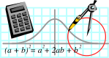  Rossmoyne SHS  Mathematics  Department | MATHEMATICS SPECIALIST 3CD | Semester 1 2011  EXAMINATION

NAME:
TEACHER: Mrs Benko Mr Birrell
Ms Robinson

Section Two:
Calculator-assumed

Time allowed for this section
Reading time before commencing work: 10 minutes
Working time for this section: 100 minutes

Materials required/recommended for this section

To be provided by the supervisor
This Question/Answer Booklet
Formula Sheet (retained from Section One)

To be provided by the candidate
Standard items: pens, pencils, pencil sharpener, eraser, correction fluid, ruler, highlighters

Special items: drawing instruments, templates, notes on two unfolded sheets of A4 paper, and up to three calculators satisfying the conditions set by the Curriculum Council for this examination

Important note to candidates
No other items may be taken into the examination room. It is your responsibility to ensure that you do not have any unauthorised notes or other items of a non-personal nature in the examination room. If you have any unauthorised material with you, hand it to the supervisor before reading any further.
Structure of this paper

Section | Number of questions available | Number of questions to be answered | Suggested working time  (minutes) | Marks  available
Section One:  Calculator-free | 9 | 9 | 50 | 40
Section Two:  Calculator-assumed | 13 | 13 | 100 | 80
 |  |  |  | 120

Instructions to candidates

- The rules for the conduct of Western Australian external examinations are detailed in the Year 12 Information Handbook 2010. Sitting this examination implies that you agree to abide by these rules.

2. Answer the questions according to the following instructions.

Section Two: Write answers in this Question/Answer Booklet. All questions should be answered.
Show all your working clearly. Your working should be in sufficient detail to allow your answers to be checked readily and for marks to be awarded for reasoning. Incorrect answers given without supporting reasoning cannot be allocated any marks. For any question or part question worth more than two marks, valid working or justification is required to receive full marks. If you repeat an answer to any question, ensure that you cancel the answer you do not wish to have marked.
It is recommended that you do not use pencil except in diagrams.

3. You must be careful to confine your responses to the specific questions asked and to follow any instructions that are specific to a particular question.

- Spare pages are included at the end of this booklet. They can be used for planning your responses and/or as additional space if required to continue an answer.
  - Planning: If you use the spare pages for planning, indicate this clearly at the top of the page.
  - Continuing an answer: If you need to use the space to continue an answer, indicate in the original answer space where the answer is continued, i.e. give the page number. Fill in the number of the question(s) that you are continuing to answer at the top of the page.

QUESTION | MARKS AVAILABLE | STUDENT MARK
10 | 5
11 | 3
12 | 5
13 | 4
14 | 5
15 | 4
16 | 13
17 | 4
18 | 4
19 | 5
20 | 5
21 | 8
22 | 15
TOTAL | 80

10. (2, 3 = 5 marks)
Given z = 3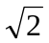+3i and w = - 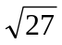- 3i.
- Express z and w in exact polar form.

(b) If v = a cis b where a and b are real constants, find a and b given that
vz = 42 cis 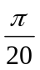

11. (3 marks)
Sketch the locus of all points on the complex plane which satisfy:
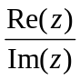 > 1 and 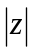 ≤ 2.

12. (5 marks)
The elliptical graph shown below has the equation 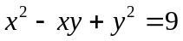.

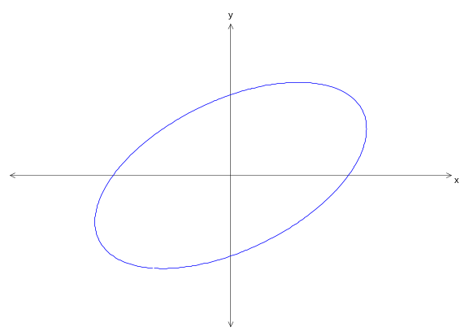

Use implicit differentiation to determine the points on the graph where the tangent is vertical.
13. (4 marks)
The vertices of the triangle ABC have coordinates A(-3, 1, 10), B(7, 1, 0) and C(-7, 5, 2).
The point D divides 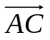 internally in the ratio 5:3. Find the vector 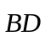.

14. (5 marks)
Use proof by exhaustion to prove that:
For integer x, x > 1, x- x is always a multiple of 6.
15. (4 marks)
Show how to solve 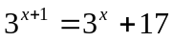 exactly using natural logarithms.

16. (2, 2, 2, 4, 3 = 13 marks)
Find the following indefinite integrals using calculus techniques:
(a) 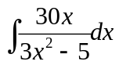

(c) 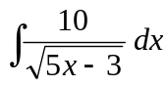

(d) 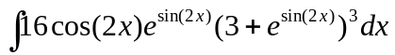

(e) 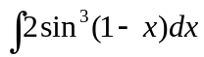

(f) 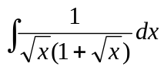 (Hint: Let u = 1 + )

17. (4 marks)
Find , in terms of x, given x = cos2t and y = 4sin2t.
Show sufficient working to justify your answer.

18. (4 marks)
Solve 10xy = 7 given y = 2 when x = 1.
19. (5 marks)
The solution to the differential equation 2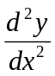 - 3 + y = -2x + 5 is given as
y = e+e+ax + b.
Find the values of a and b. Show your reasoning clearly.

20. (5 marks)
Show that 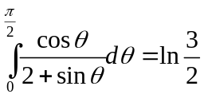.
21. (4, 3, 1 = 8 marks)
The x axis and the curves y = ln (x-2) and 2y = ln x fully enclose a region R in the first quadrant.
(a) By first considering areas between the curves and the x axis, express the area of R in terms of integrals with respect to x.

- By considering areas between the curves and the y axis, express the area of R terms of an integral with respect to y.

(c) Evaluate the area of R giving your answer correct to three decimal places.
22. (6, 3, 6 = 15 marks)
Consider the plane 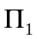: r. 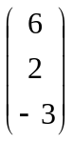 = 4
(a) Determine the equation of the plane(s) parallel to and exactly 14 units away.

The line L: r = 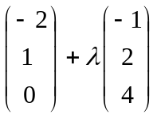 intersects at the point P.
(b) Determine the coordinates of the point P.

(c) Determine the exact minimum distance between the line
L: r = 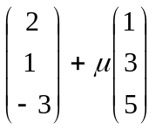 and the point P. You must fully justify your solution.
Extra Page …..
Extra Page …..

